skills can be applied efficiently and effectively in order to develop my career aiming at the growth of the company.

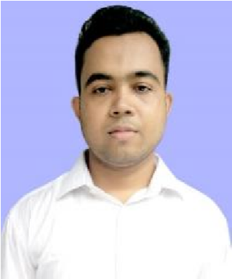

**Md. Shovon Parvez**

Town Sreepur,

Debhata,

Satkhira

, Bangladesh.

E

-

mail:

shovonparvez880

@

gmail

.com

Mobile No: +88

-

01779

770619



**Career Objective**

*:*

To

seek an

execut

ive

position

in a dynamic organization where my academic learning

and



***Educational Qualifications***

***:***



**B.**

**B.A (**

**Bachelor of**

**Business**

**Administration**

**)**

**Name of the College :** Satkhira Govt. College, Satkhira, Bangladesh.

**Subject :** Accounting

## CGPA : 3.10

## Session : 2014-15

**Board/University :** National University.

 **H.S.C (Higher Secondary Certificate)**

**Name of the College :** Debhata College, Debhata, Satkhira, Bangladesh.

**Group :** Business Studies

## Obtained GPA : 4.30

## Year of passing : 2014

**Board :** Jessore.

 **S.S.C (Secondary School Certificate)**

**Name of the School :** Town Sreepur Secondary School,Town Sreepur, Debhata, Satkhira, Bangladesh.

**Group :** Business Studies

## Obtained GPA : 4.44

## Year of passing : 2012

**Board :** Jessore.



***Personal Qualifications:***

* Sound Presentation Skill ❖ Hard Worker.
* Excellent Team Leader.
* Like to Meet and Take Challenges
* Goal Oriented Person
* Capable of working in a team as well as independently, ❖ Strong communication and interpersonal skills.
* Able to work under pressure.



***Computer Literacy:***

* Microsoft Word, Microsoft Power Point, Photoshop, Microsoft Excel; ❖ Online Browsing & Computer Assembling.
* Windows Service Pack 2, Service Pack 3; Windows Vista;

*Page: 01 to 02*



***Language Proficiency:***

## Language Reading Writing Speaking

* Bangla High High High
* English High High High



**Interests and Hobby**

To work and gain experiences in job world. Also like reading books, listening music, traveling to different places, and photography.



**Personal Information:**

|  |  |  |  |
| --- | --- | --- | --- |
|  |  | Name | : Md. Shovon Parvez |
|  |  | Father's Name | : Md. Abdus Salim Gazi |
|  |  | Mother's Name | : Rawshan Ara Khatun |
|  |  | Date of Birth | : 23.09.1996 |
|  |  | Nationality | : Bangladeshi |
|  |  | Marital Status | : Unmarried. |
|  |  | Height | : Fife fit Seven Inch |
|  |  | Religion | : Islam |
|  |  | Blood Group | : O+ (Positive) |

**Present and Permanent *Address:***

|  |  |  |  |
| --- | --- | --- | --- |
|  |  | Village | : Town Sreepur. |
|  |  | Post Office | : Town Sreepur. |
|  |  | Police Station | : Debhata. |
|  |  | District | : Satkhira. |



***References:***

# Abul Hashem 2. Md. Sariful Islam



Professor Office In Charge

Satkhira Govt. College Breaking the Silence

Satkhira. Satkhira Office

Accounting Department Satkhira

Mobile: 01720 526055 Mobile: 01720 537237



***Declaration:***

“I do hereby declare and affirm that all information stated above is true and authentic to the

best of my knowledge and belief”.

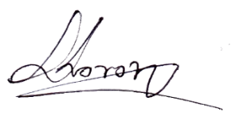 Signature :

Date : 025/03/2021

*Page 02 of 02*